

GROUP MEMBERS

Muhammad Wadid (1278782)

Nirten (1278064)

Talha Sajjad (1277942)

Wali Muhammad (1278164)

Table of Content

* Introduction Page # 1
* Acknowledgement Page # 2
* Hardware & Software Page # 3

Requirement

* Task Sheet Page # 4
* DFD Diagram Page # 5
* Screen Shots Page # 6
* Conclusion Page # 12

ACKNOWLEDGEMENT

I would like to acknowledge all those who have given us moral support and helped in making the project a success.

I wish to express my gratitude to E-Project Team at Head Office who guided and helped us. Thanks to our Faculty

*Sir Ubaid* who guided us during the Project. Also, I would like to express my gratitude to all the staff members of my center for not only providing us opportunity to work with them on this project, but also for their support and encouragement throughout the process.

I also express my sincere gratitude to E-Project Team from Aptech Head Office and my project guide at the organization for his valuable guidance and support for completion of this project.

Final, I would like to offer many thanks to all my colleagues for their valuable suggestions and constructive feedback.

HARDWARE & SOFTWARE REQUIREMENT

Hardware:

* A minimum computer system that will help you access all the tools in the courses is a Pentium 166 or better.
* 64 Megabytes of RAM or better.

Software:

* Notepad/HTML Editor
* Visual Studio Code (VS Code)
* IE 5.0/ Netscape 6.0

TASK SHEET

|  |  |  |  |  |
| --- | --- | --- | --- | --- |
| S.NO | TASK | DAYS | GROUP MEMBERS | STATUS |
| 1 | Designing | 8 | M.Wadid  &  Nirten |  |
| 2 | Coding | 12 | M.Wadid  &  Nirten  &  Talha Sajjad |  |
| 3 | Testing | 1 | M.Wadid |  |
| 4 | Documentation | 1 | M.Wadid |  |

DFD DIAGRAM

HOME

LOGIN

ABOUT US

CONTACT US

SHOP

SHOP BY BRAND

EDUCATIONAL TOYS

SHOP BY AGE

BEST SELLERS

HOT WHEELS

PLAY SKOOL

NERF

MATTEL

(6-10) YEARS

(5-6) MONTHS

(1-5) YEARS

Screen Shots

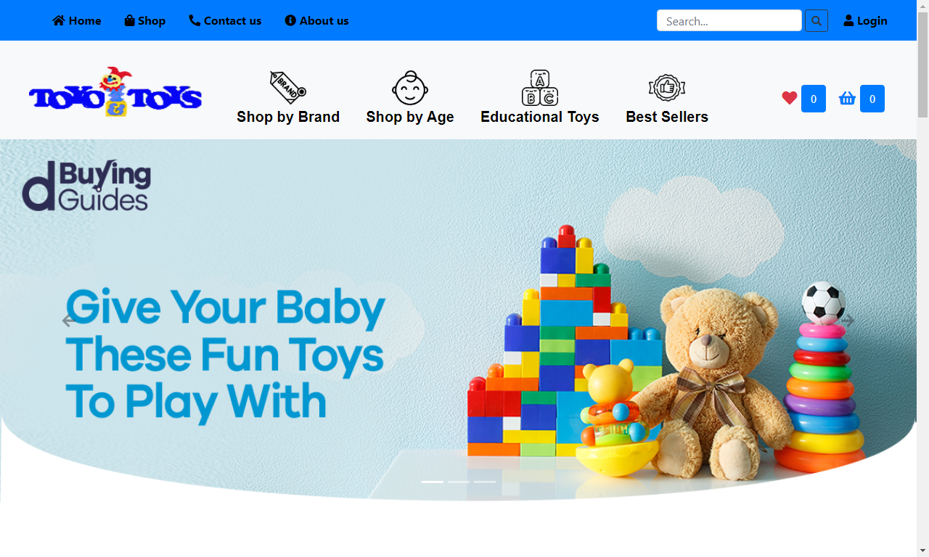

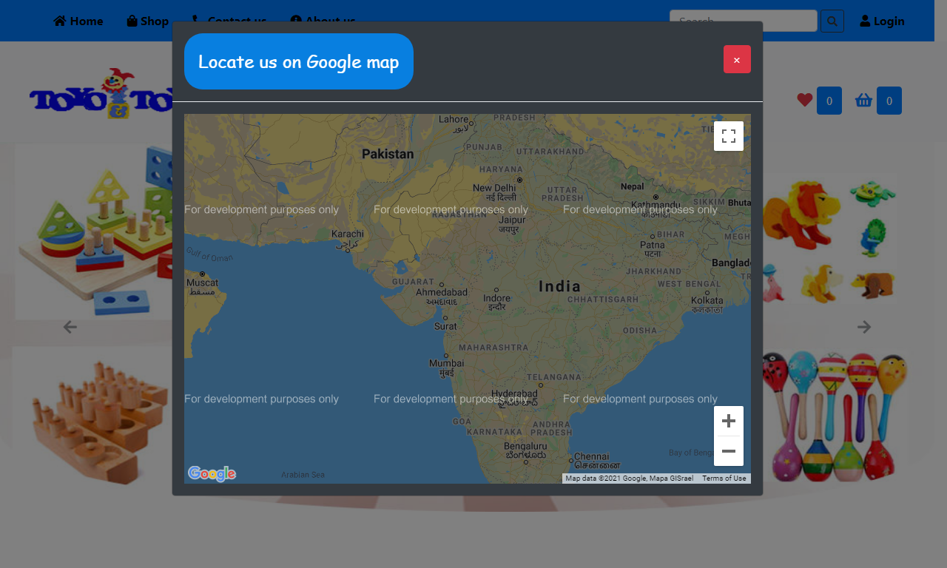

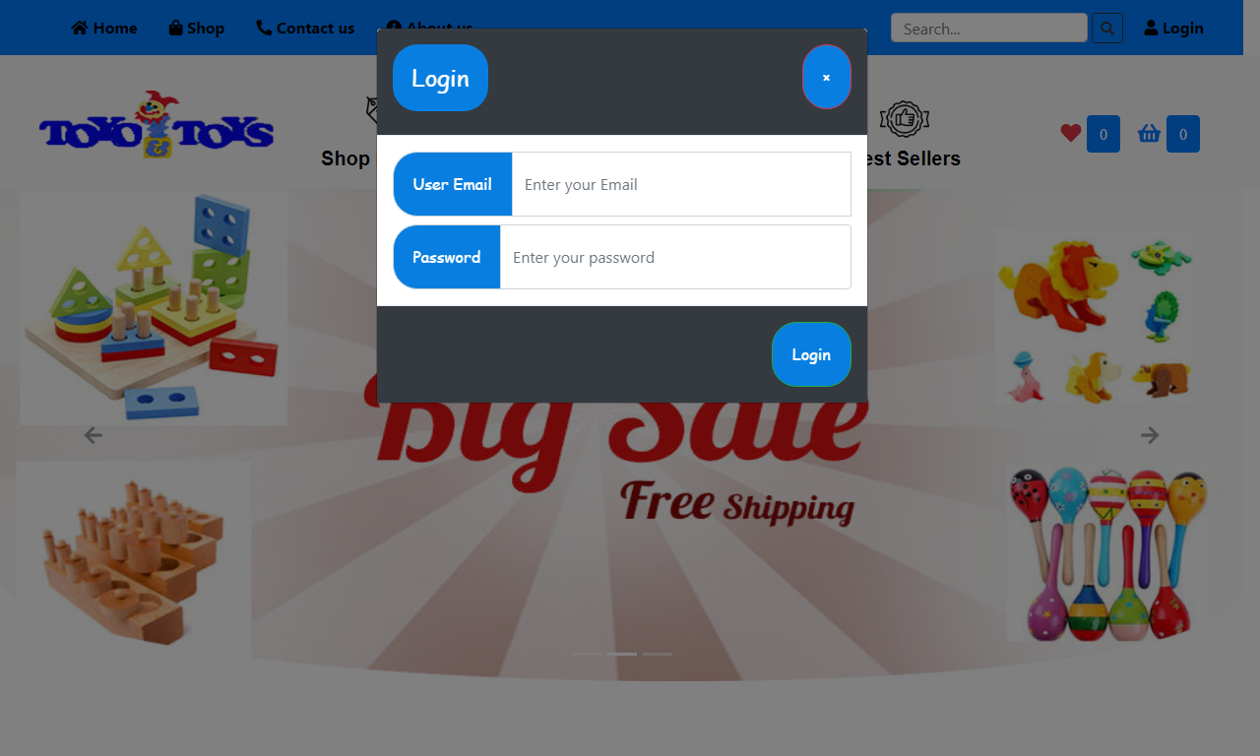

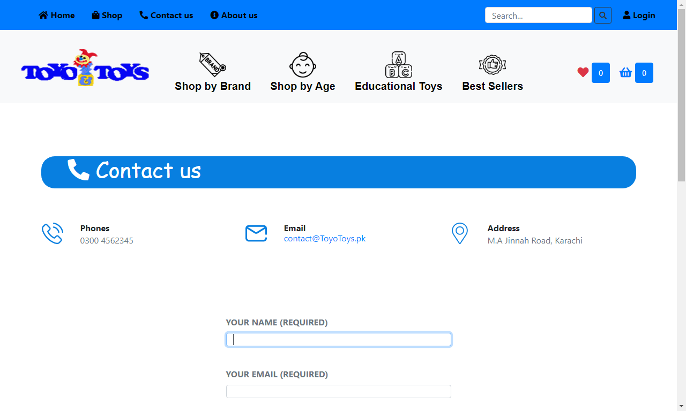

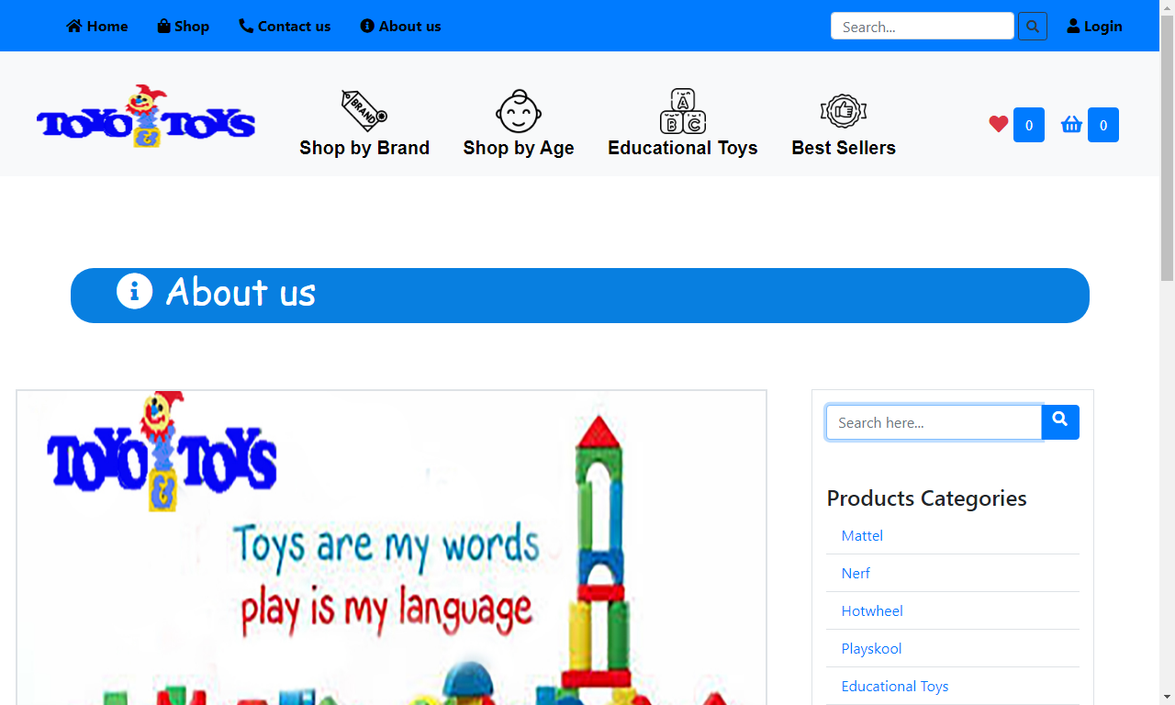

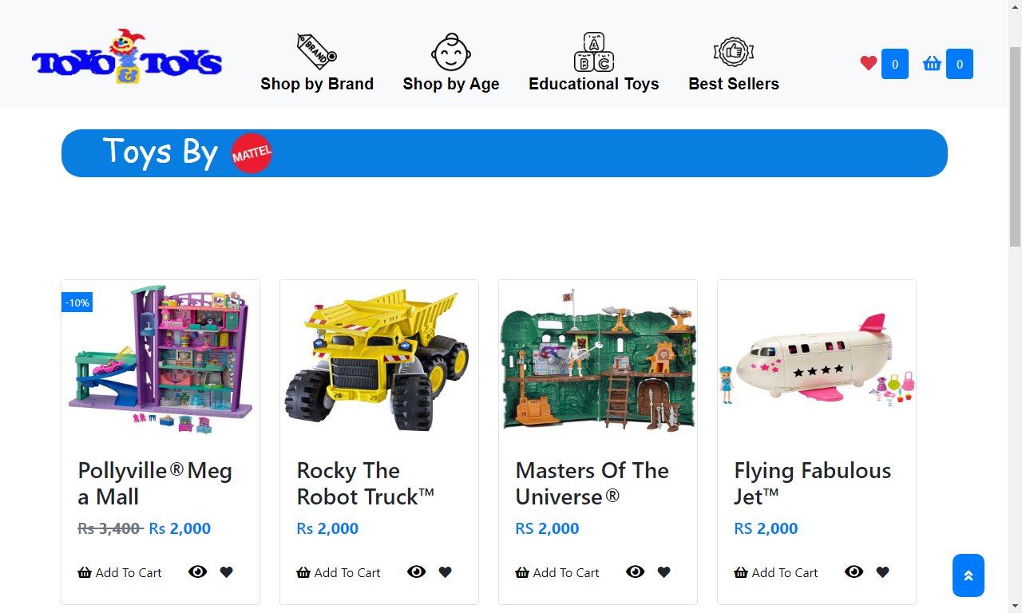

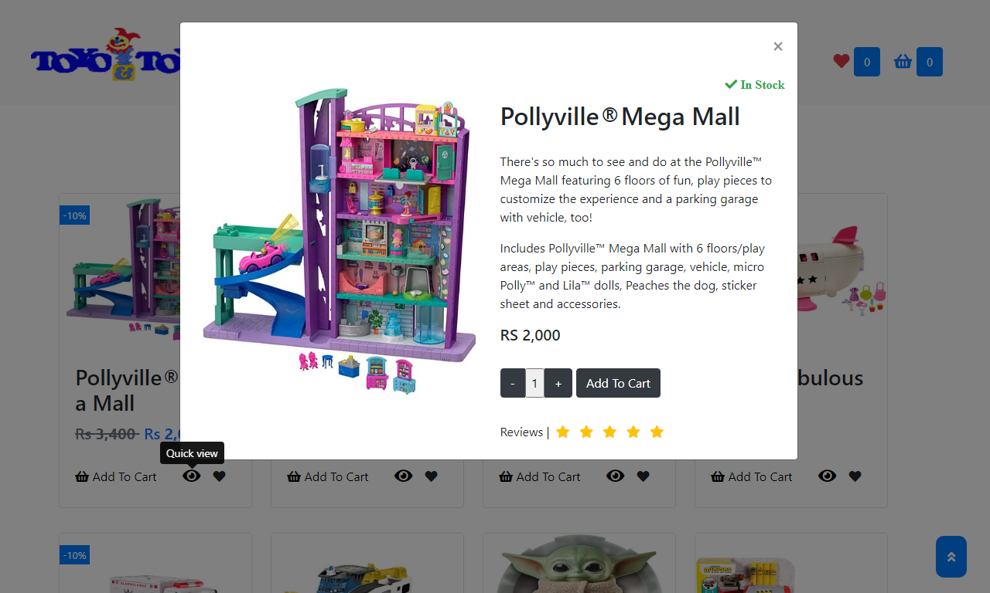

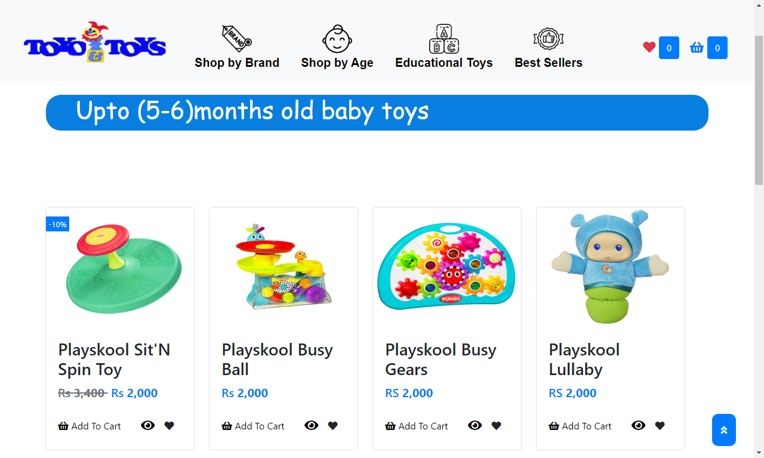

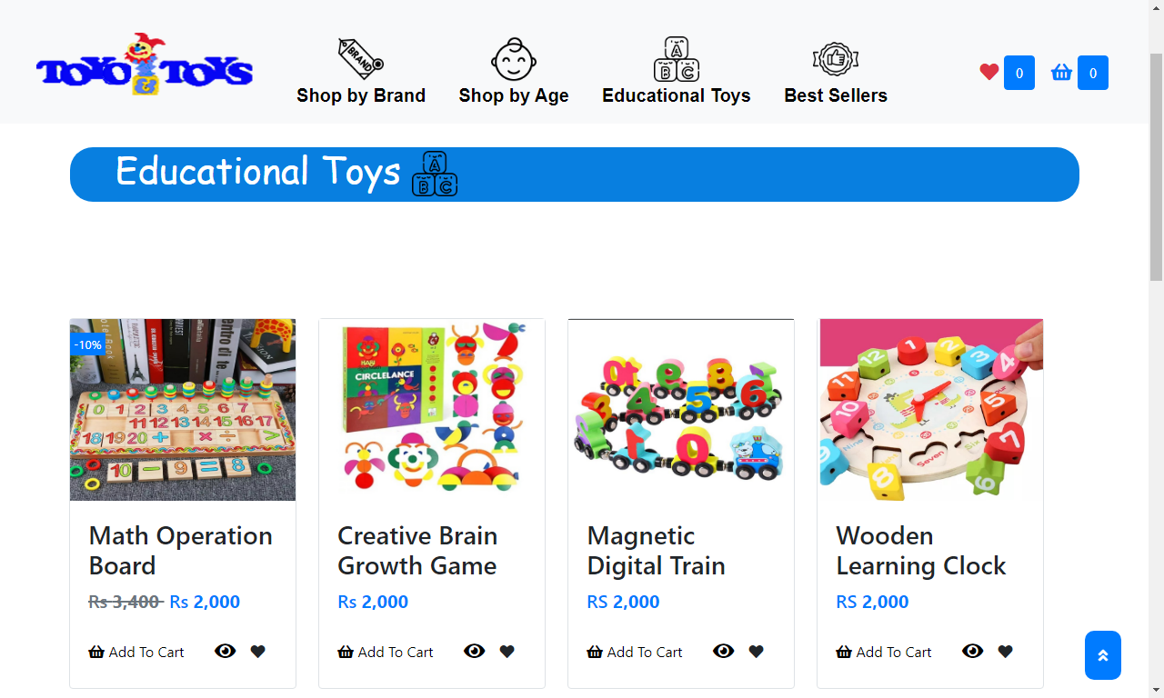

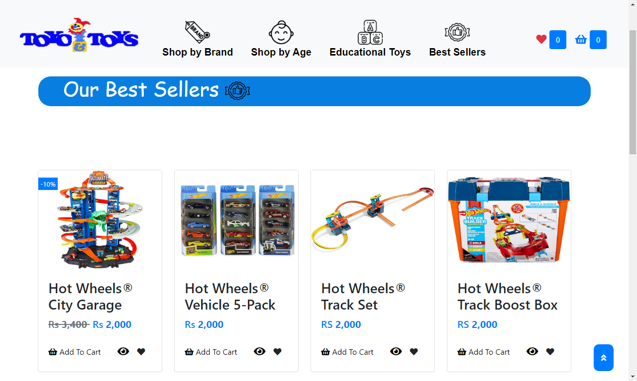

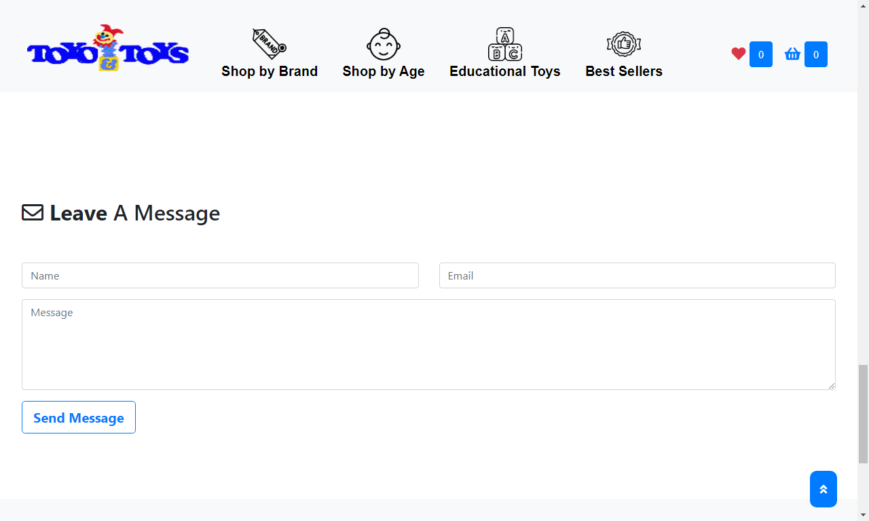

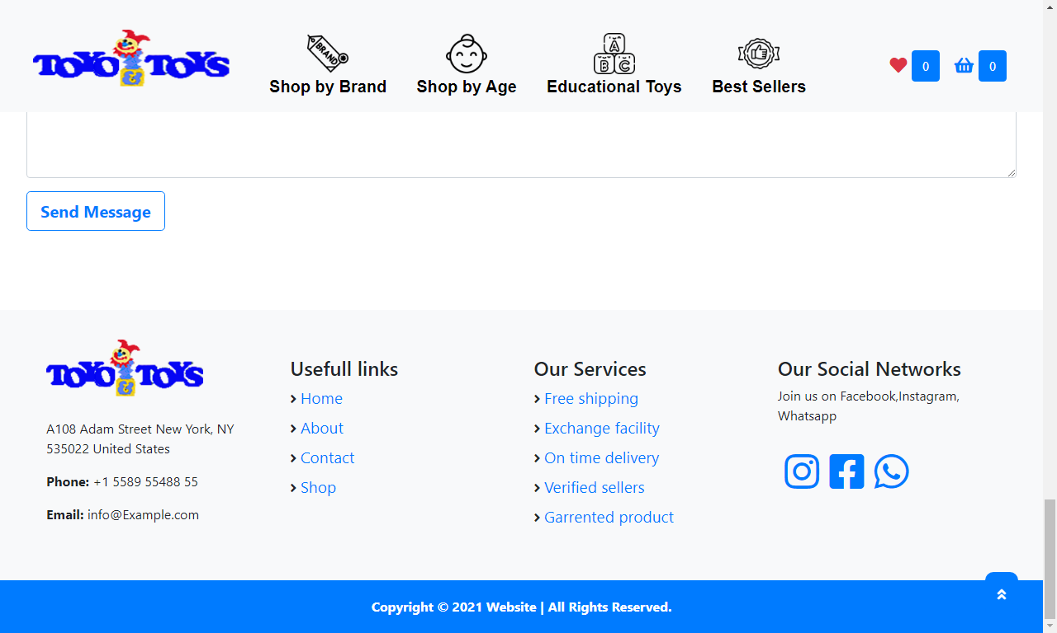

WEBSITE URL:

[toyotoys.gdn.aptech.hwssp.org](http://toyotoys.gdn.aptech.hwssp.org/)

Conclusion

It was a wonderful and learning experience for us while working on this project. This project took us through the various phase of project development and gave us real insight into the world of Information Technology (IT). The joy of working and thrill involved while tackling the various problem and challenge gave us a feel of developers industry.

I enjoy each and every bit of work. I had put into this project. Thank you for each and every person who support us especially *Sir Ubaid*.

THANK YOU